**E-Kaizen 5S guideline – how to submit new kaizen**

1) Log into *Carsem Web system* and select *5S*.

2) Under *eKaizen* tab on the left, please select *New Form (P3 Kaizen)* to key in new kaizen.

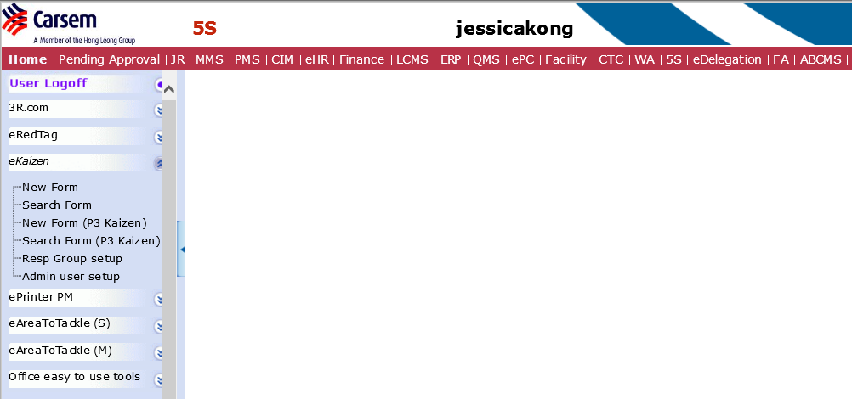

**2**

**1**

3) In *new Form (P3 Kaizen)*, you will be able to see the format to key in all the kaizen information.

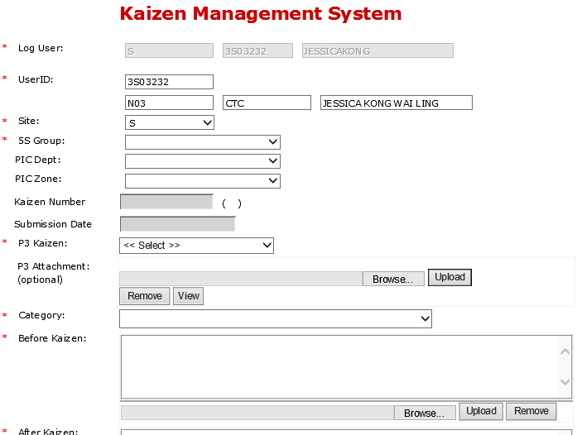

**E-Kaizen 5S guideline – how to see Summary of kaizen submitted**

1) Under *eKaizen* tab on the left, select *Search Form (P3 Kaizen)* to see all the kaizen submission.



**1**

2) In *Search Form (P3 Kaizen)*, you will be able to see all the kaizen submitted (as below).

